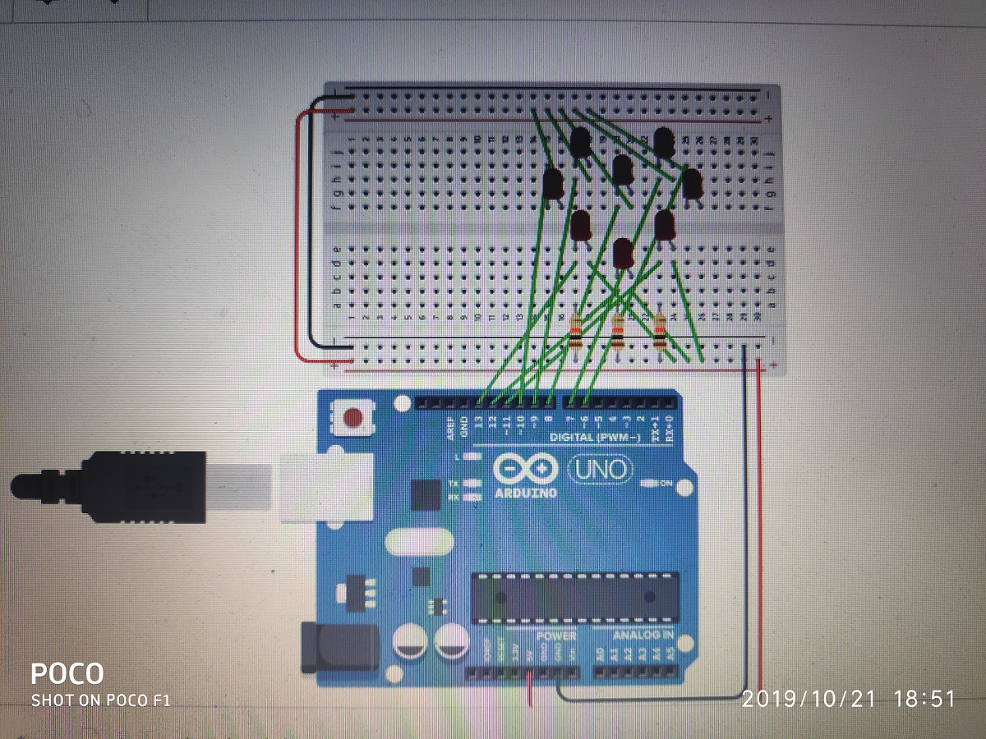

Theory-:

1. When different led are connected in heart shape on a breadboard. And connected with a arduino with 5v supply and grounding wire.
2. After writing the code led’s blink for 60 times
3. And stop after 60 blinks.

Learning and observations-:

1. Blinking pattern observed in heart shape
2. Use of multiple led to make desired shape
3. Led stops blinking after 1 minute.
4. Blinks 60 times a minute

Problems faced-:

1. Making heart shape using led was not difficult but the connection was a little difficult.
2. Coding was a moderate task to be done

Precautions-:

1. Make connections right or it will not work
2. Use suitable resistances.
3. Make proper use of connecting wires.

Learning outcomes-:

1. Got good amount of knowledge about led blinking
2. Able to learn to make different shapes on breadboard.
3. Able to learn different patterns and time shift for led’s